**Determinants of bank performance: ROE, ROA profitability measures amongst Islamic and Conventional banks in the GCC**

[Month] 20XX

Carnegie Mellon University

**Abstract**

**Introduction**

**Literature Review**

The empirical literature on bank’s performance focuses primarily on assessing the relationship between bank’s performance measures such as ROE and ROA and several predictors of bank’s performance based on fundamental data such as net interest margin, loan loss provision ratios etc. These factors often are combined with general macroeconomic factors such as GDP growth that act as control variables.

Some of the recent work on this topic includes research by Athanasoglou (2008)[1], Dietriech (2011)[2], Kohlscheen (2018)[3], Vong (2014)[4], Alexiou (2009)[5], Petria (2013)[6], Heffernan (2008)[7]. The common theme and framework among these studies is to look at explanatory variables, often bank related and macroeconomic variables, and their impact of some measure of bank’s performance i.e.: ROA or ROE. These studies often focus on regional or country specific banks. Some extend the study to consider the impact of a severe economic event such as the 2007 financial crisis. The results of these empirical studies while providing different and sometimes contradictory results about the impact of specific variables on banks’ performance due to sample differences tend to agree on broad conclusions.

Heffernan (2008)[8] evaluates the determinants of performance for national, urban only and rural, 76 banks from 1999 till 2006, a period of major structural reforms for china’s banking sector and finds that cost to income ratio has a significant and negative impact on ROE but not on ROA suggesting that efficient banks; banks with lower cost to income ratio; perform better on at least one of the measures of banks performance. Listed banks have a significant positive higher ROE measure compared to banks that aren’t listed but a significant negative ROA compared to the non-listed banks leaving ambiguous the conclusion on the impact of being listed versus private on a bank’s governance and hence performance. Heffernan also finds that size and foreign ownership doesn’t seem to have a significant impact on performance. The impact of loan loss reserves ratio is positive and significant on performance and seems to be a counterintuitive result of Heffernan’s study.

Alexiou (2009)[9] in an analysis of the Greek banking sector finds that for bank related variables size has a positive and significant relationship with performance. While credit risk, bank productivity, efficiency ratio, loans to deposits have a significant but negative relationship with performance. Other bank related variables and macroeconomic variables such as inflation and GDP didn’t have significant relationship with performance. Alexiou’s results seem to corroborate the idea that larger banks benefit from economies of scale and enjoy a relative market power position that helps them enjoy greater performance gains. The results also show that banks that undertake riskier activities and increasing their loans and loan loss reserves, along with their non-interest expenses and their loan books relative to their deposits suffer performances loses.

Athanasoglu (2008)[10] looking at a more extensive data set of banks spanning the period 1985 to 2001 in Greece finds that bank as measure by the ratio of total equity to total assets is significant and positive with ROA, reflecting the idea that better capitalized banks showcase better performance in the Greek banking sector. Credit risk measured by loan loss provisions to total loans on the other hand is negatively and significantly related to ROA. Size, ownership, concentration measured by H-H index don’t appear to have significant relationships with ROA. Business cycle trends, in particular in comparison to the business cycle trend appear to have a significant relationship with performance when the output or GDP change is above trend while it remains non-significant when the GDP change is below trend. Finally, Athanasoglu finds that inflation is positively and significantly related to performance which in turn showcases that banks are able to forecast inflation correctly and adjusting their interest rates and expectations on bond & treasury yields accordingly.

Dietriech et al (2011)[11] follow a slightly difference approach by accounting for major economic events, in this case the financial case of 2007, and looking at the relationship between bank’s performance and a set of bank and macroeconomic characteristics before and after the crisis, as well as during the overall period from 1999 to 2009, with and without accounting for a set of market specific factors. Their study shows that capital ratio measured by equity to total assets didn’t have a significant relationship on bank performance after the crisis as compared to before the crisis, meaning that well capitalized banks don’t seem to perform better than their less capitalized counterparts after the crisis. However, when looking at the relationship before the crisis, the results show a negative and significant relationship between the capital ratio and bank performance. The proposed explanation to the post crisis state was the safer Swiss bank studied increased their deposits without managing to increase their lending during that period. Cost to income, the operational efficiency measure in the study, had a negative relationship with performance for all periods. On the other hand, credit quality measure of loan loss provision to total loans wasn’t significantly related to the bank’s performance pre-crisis but was negatively and significantly related to it afterwards. This was a result of the increasing lower quality of bank’s loan books post crisis which weighed down on profitability. In respect to Size, the researchers found some evidence of significant relationship with bank performance but mainly after the crisis for larger banks that held larger loan loss provisions that weighed on their performance. Ownership stats seems to be irrelevant in explaining bank performance.

As for the macroeconomic determinants, Dietriech et al find that the business cycle stage affects bank performance with business cycle upswings and performance being significantly and positively related for all periods. Interest rates are also positively related to bank performance overall and after the crisis. H-H index of market power has significant positive relationship with performance before the crisis but not after.

Petria (2013)[12] research takes a more comprehensive approach in looking at banks across 27 EU countries over 2004-2011 increasing the cross-section differences in macroeconomic variables. The study finds that when looking at banks across the 27 European countries for the period size doesn’t appear to have a significant a relationship with either ROE or ROE, the selected measures of performance for the study. Cost to income ratio, liquidity risk and the credit risk ratio on the other hand have a significant negative relationship with ROA and ROE. The macroeconomic and industry factors provide some contrasting evidence to previous research. The inflation rate doesn’t seem to have significant relationship with either of the banks’ performance measures. The case is similar for the GDP growth rate as well as the market concentration as measured by the H-H index.

One of the most recent studies on bank performance determinants comes from Kohlscheen (2018)[13] which also looks at a set of banks across different countries, this time specifically focusing on emerging markets from 2000 to 2014

**Background**

Our research question is motivated by a gap in the literature focusing on the differences between Islamic and conventional banks particularly the ambiguous profitability patterns amongst GCC banks. The common assumption is that the difference in business models between Islamic and conventional banks particularly in GCC countries leads to potential differences that go beyond differences in profitability to include differences in business orientation, cost efficiency and capital and balance sheet soundness.

However, within our sample, we find that while some differences emerge between Islamic and conventional banks, they are more often country specific and harder to generalize to the sample highlighting that these supposed differences between the two sectors don’t translate into their financials. This could potentially be a product of the accounting standards that might not be able to fully capture business model differences. It is also possible that differences aren’t emerging because the two sector balance sheets have somewhat similar exposures, primarily dominated by either financing government and large business projects or owning government treasuries, bonds and sukuks.

We explore the historical evolution of some of the key profitability measures as well as several bank specific profitability determinants to highlight the observations mentioned above.

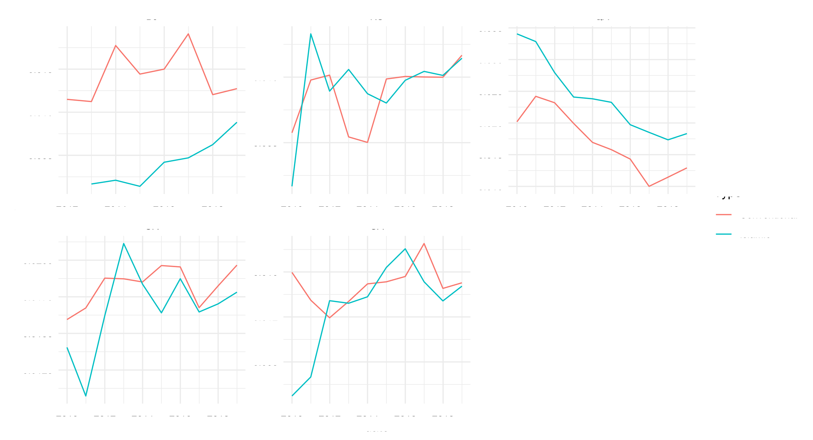

*Figure 1 Evolution of ROA level between Islamic and Conventional Banks*

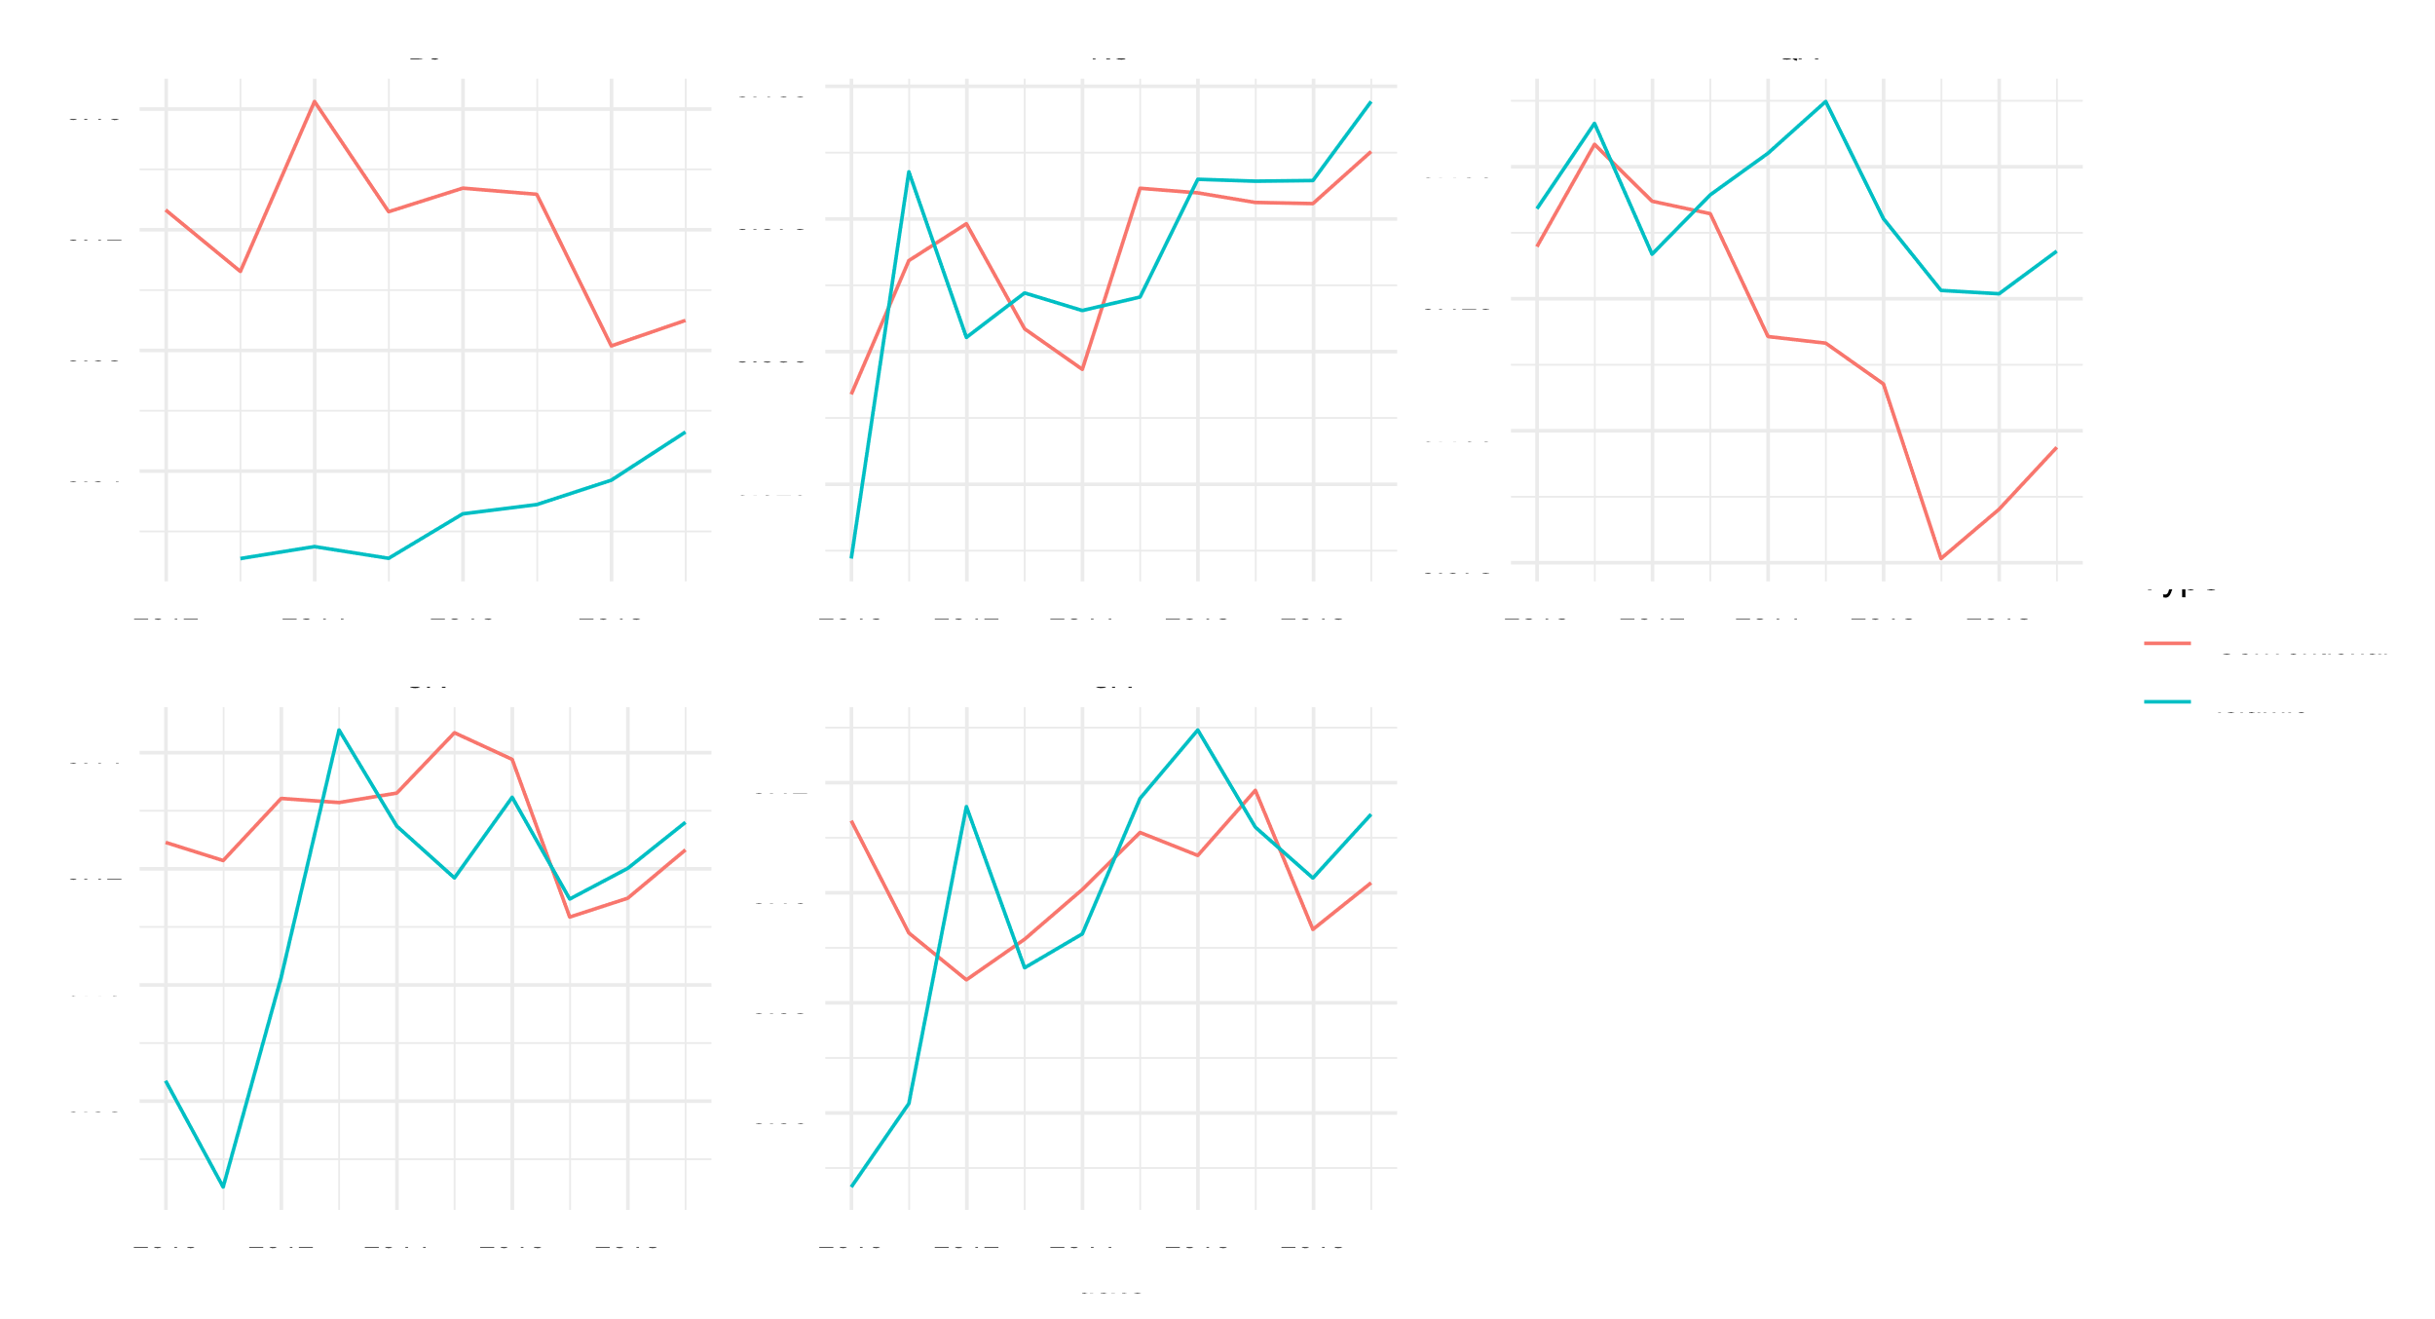

*Figure 2 Evolution of ROE level between Islamic and Conventional Banks*

Regarding the ambiguity in profitability, we find that in some countries such as Qatar or Bahrain, the Islamic vs Conventional banks divide in profitability measures is clear. In the case of Bahrain, the conventional banking sector has been historically more profitable than the Islamic banking sector on both ROE and ROA measures. In Qatar on the other hand, Islamic banks appear to have historically outperformed conventional banks in both ROE and ROA profitability measures. For the remaining GCC countries in our sample, conventional and Islamic banks have on average equal profitability levels.

**Business Model and Orientation**

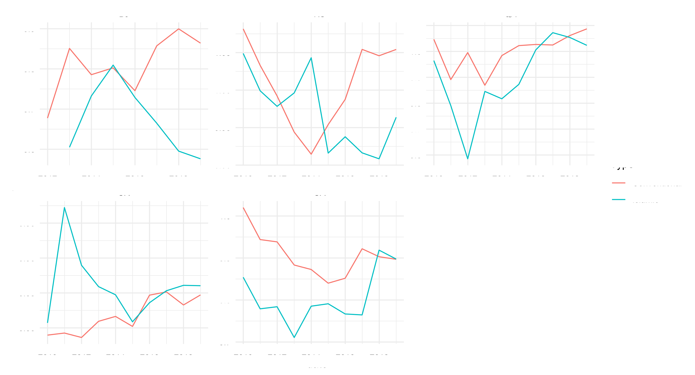

*Figure 3 Evolution of Loans to Deposits ratio between Islamic and Conventional Banks*

Islamic banks on average have lower loans to deposits ratios than their conventional counterparts. It is possible that the limited financing opportunities for the Islamic banks drive them to allocate more of their asset side into investments (Sukuks and equities) than loans. We think Islamic banks have a higher Investments to Total Assets ratio than conventional banks.

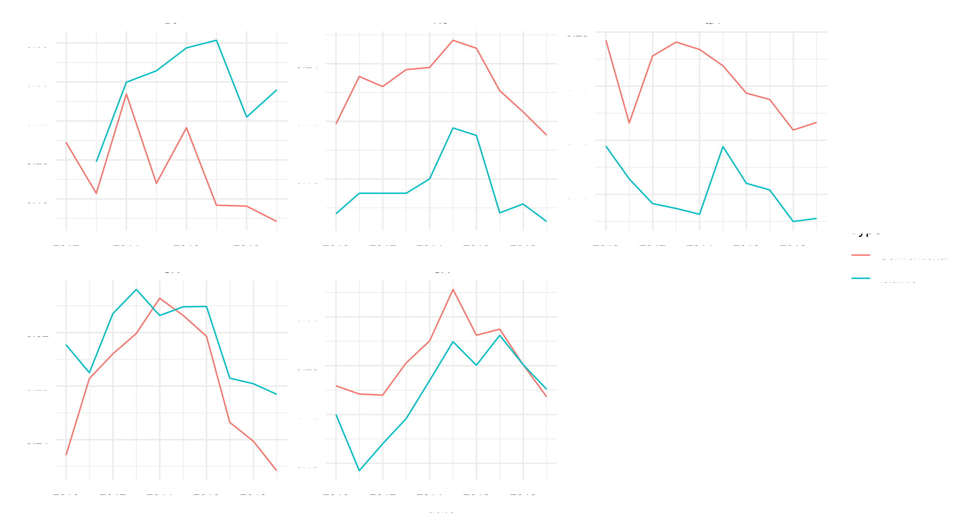

*Figure 4 Evolution of fee-based income ratio between Islamic and Conventional Banks*

Islamic banks have lower fee-based income as a percentage of total income in aggregate compared to the conventional banks. This is probably due to lower intermediation activities such as: brokerage services, M&A advisory etc. We think the proportion of revenue from Fee based activities vs Interest Based Activities is different across the two sectors. We think Islamic banks drive their revenue primarily from interest based (profit sharing) activities.

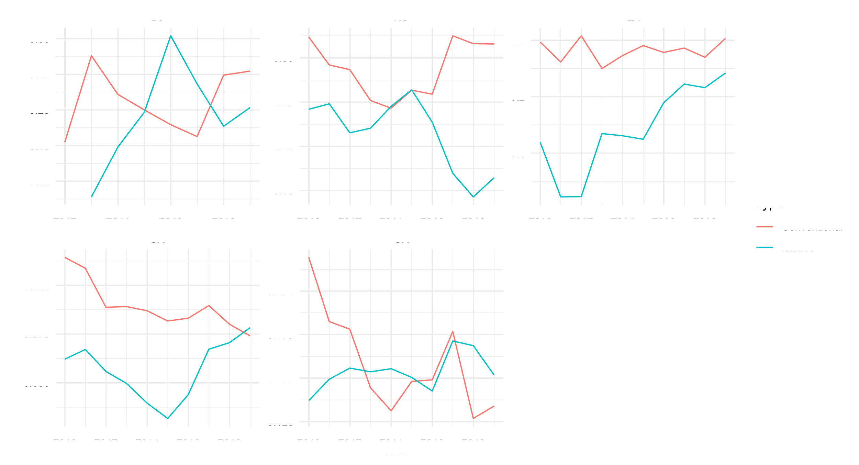

*Figure 5 Evolution of non-deposit funding between Islamic and Conventional Banks*

Islamic banks have a lower ratio of non-deposit funding. Given the smaller size of the sukuk market relative to conventional debt markets as well as the difficulty of tapping into repo markets, the Islamic banks rely heavily on deposits for funding.

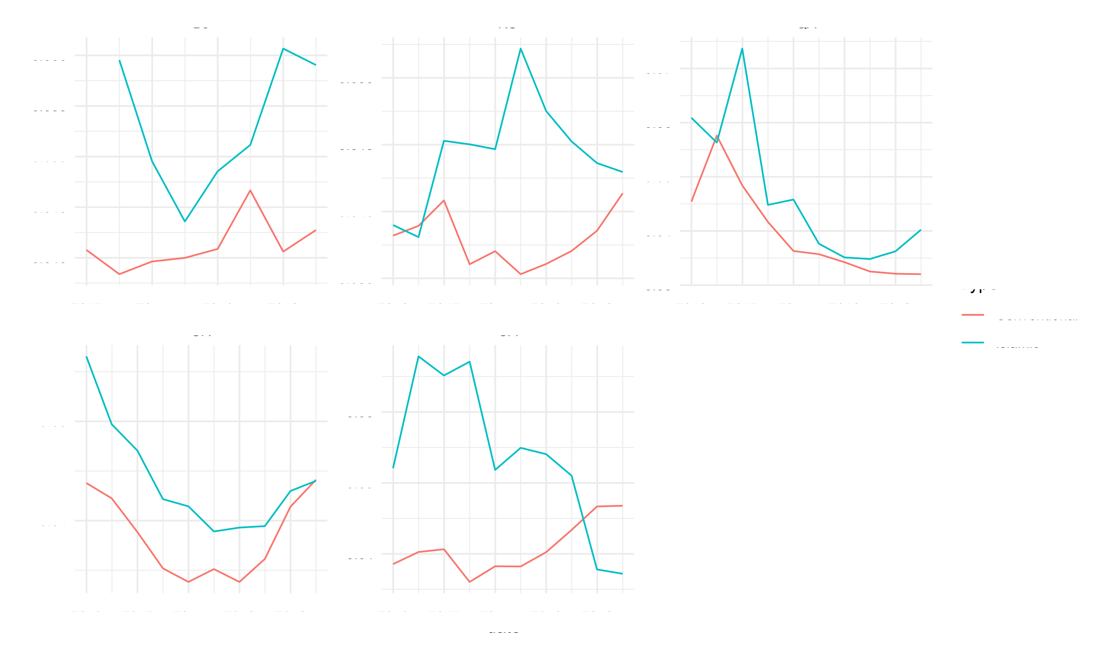

*Figure 6 Evolution of Net Interest Margin between Islamic and Conventional Banks*

Islamic banks appear to be more profitable than their conventional counterparts in the financing activities. This could be due to the higher risk these banks undertake in performing financing activities as often they are equity holders in the projects that they finance.

**Bank Efficiency Indicators**

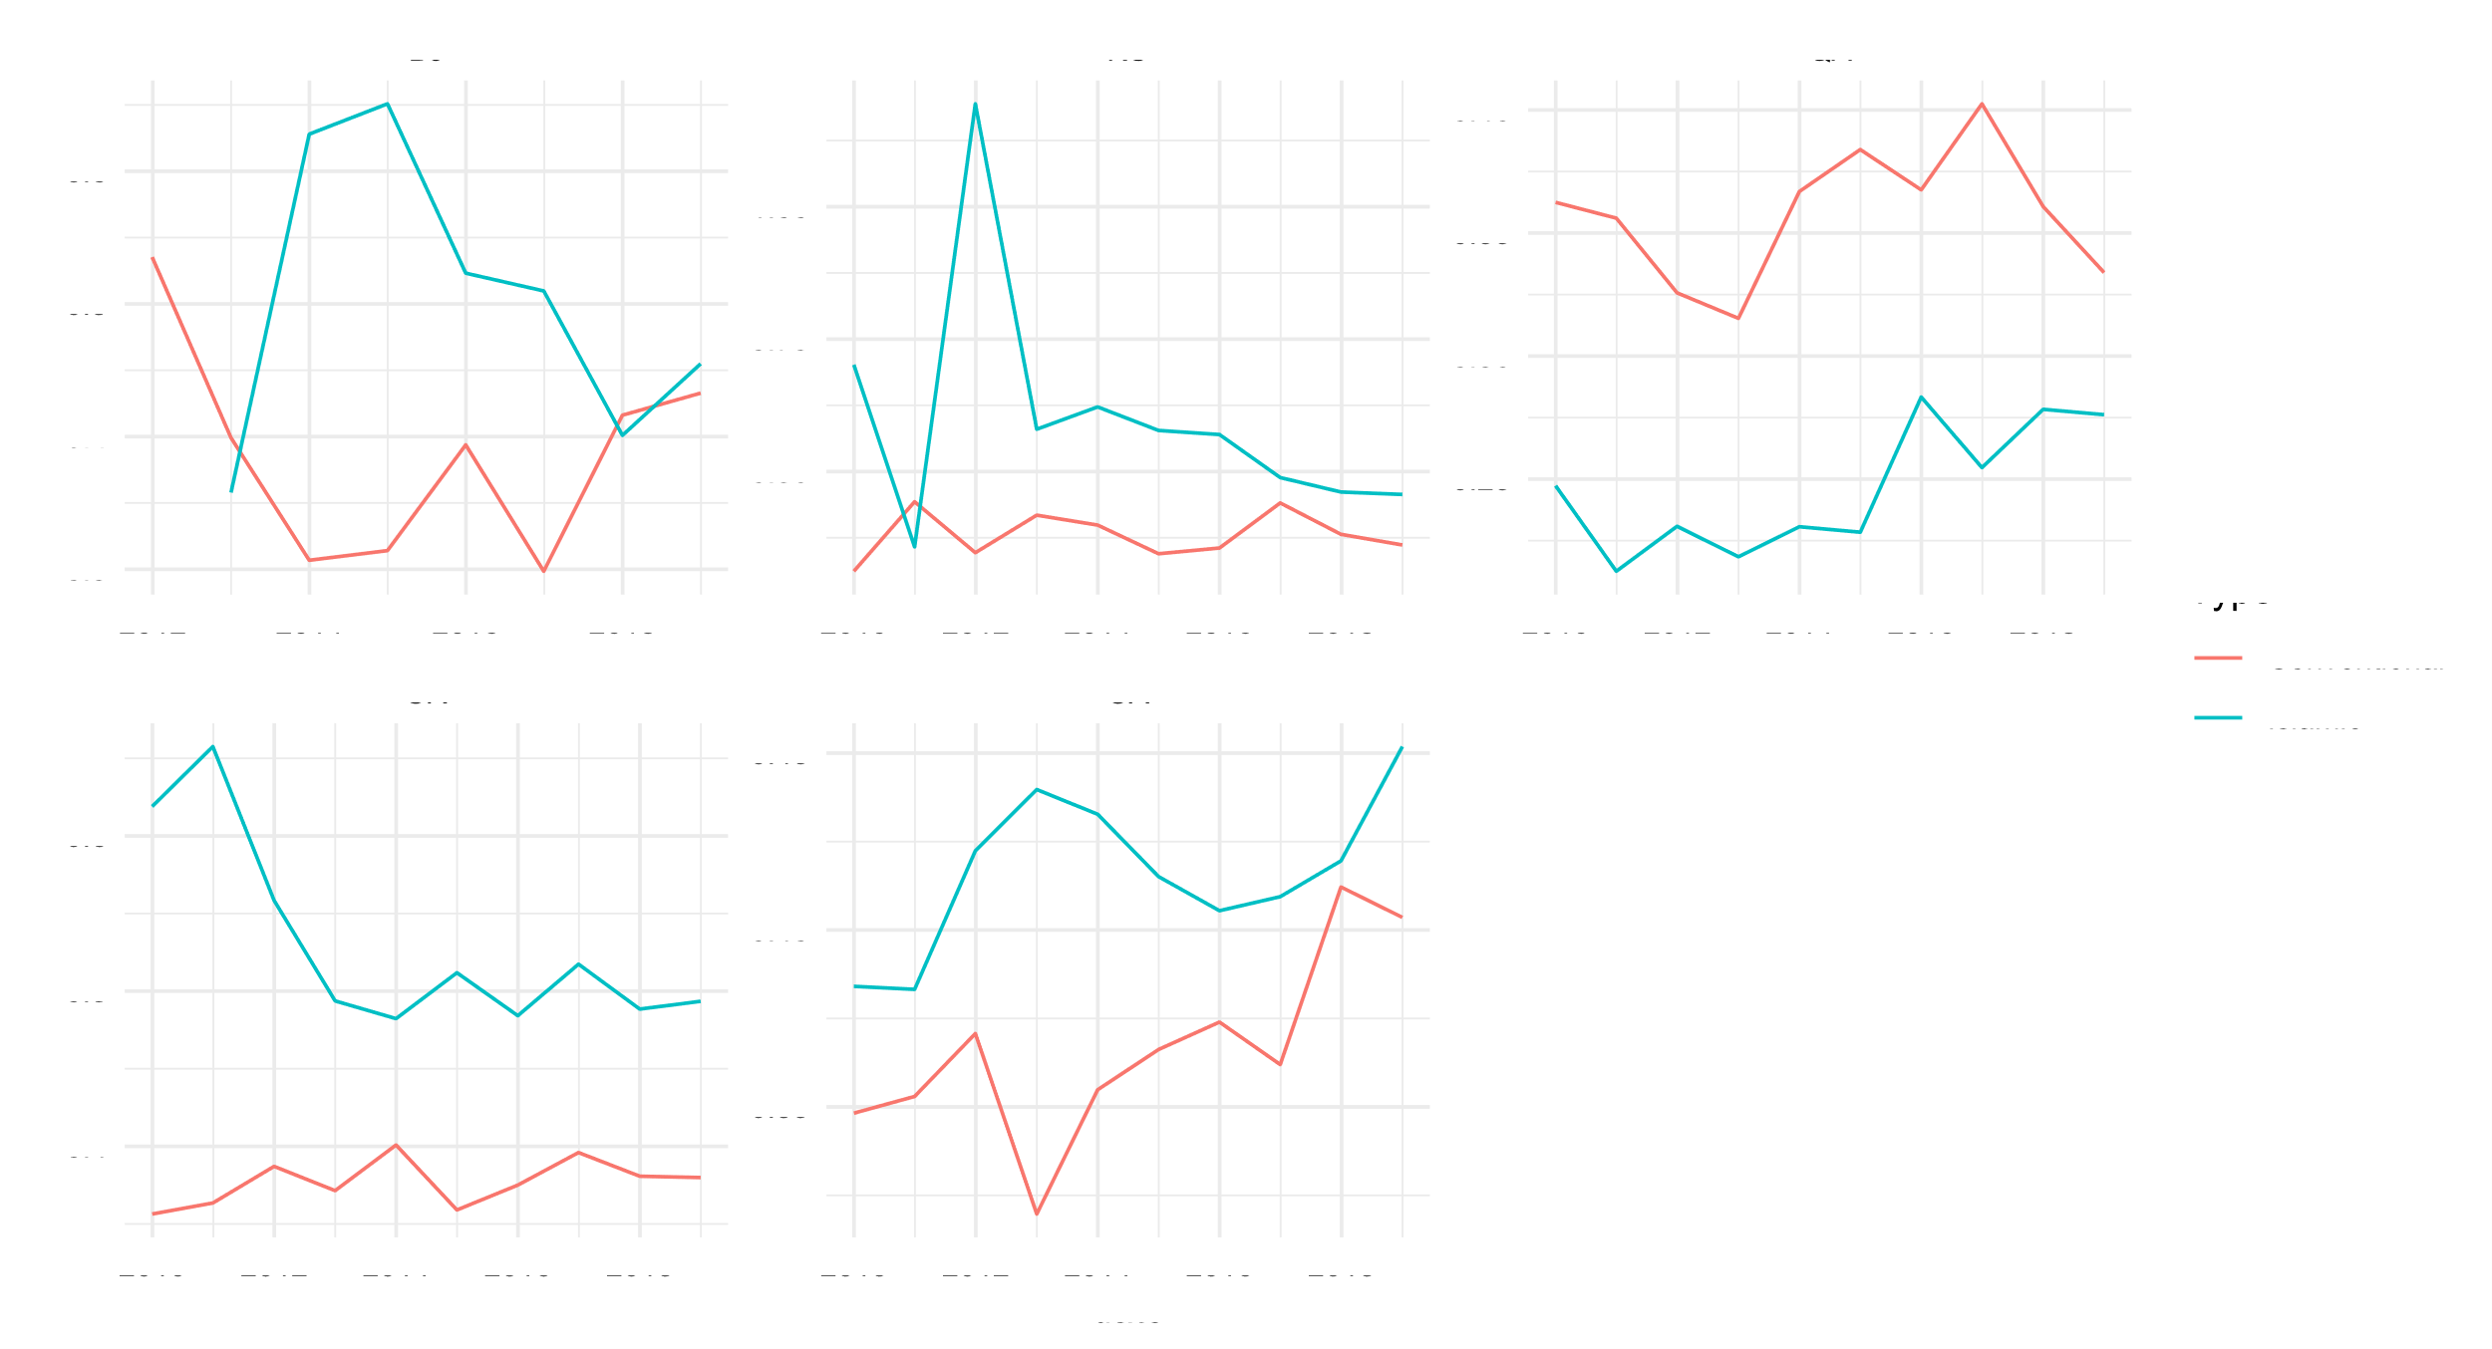

*Figure 7 Evolution of Cost to Income Ratio between Islamic and Conventional banking*

Islamic banks appear to have higher costs relative to their income which is probably associated with the higher intermediation activities due to the nature of their business model. Generally, we would expect banks that draw a higher share of their income from fee-based activities, higher fee-based income ratio, to have a higher cost to income ratio given that fee-based activities tend to be intermediation-based activities. However, in our sample we find the evidence on that to be ambiguous at best. For example, in the case of Qatar the Islamic banks tend to have a lower cost to income ratio in line with lower fee-based income ratio relative to the conventional banks. In UAE on the other hand, the Islamic banks have a lower fee-based income ratio but higher cost to income ratio.

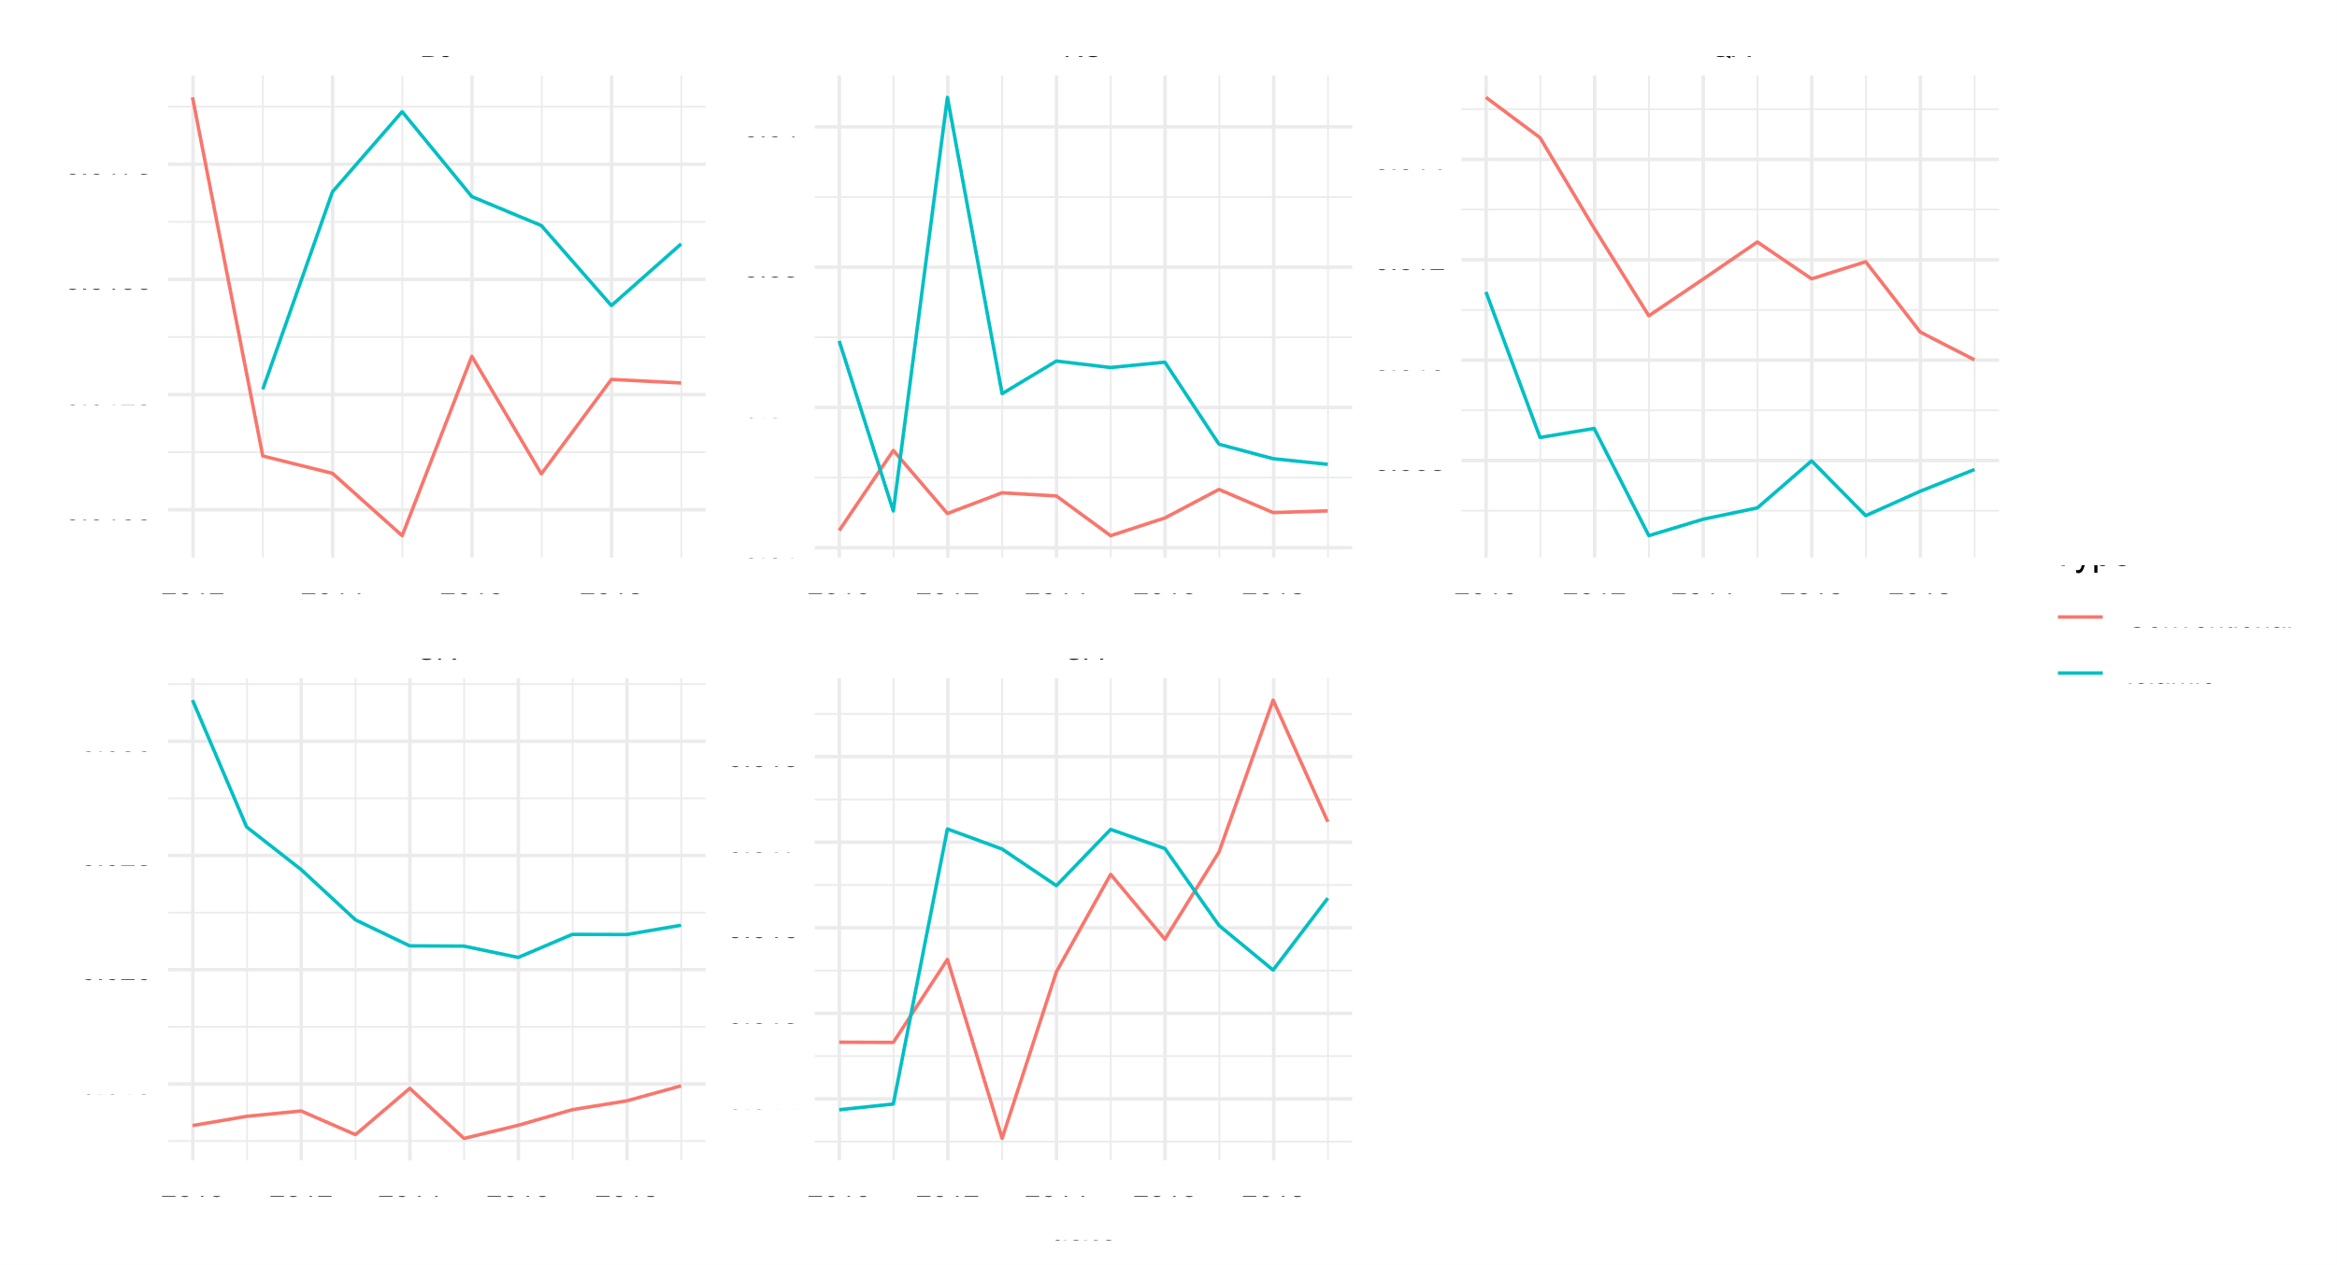

*Figure 8 Evolution of overhead cost ratio between Islamic and Conventional banking*

Islamic banks have higher overhead costs relative to conventional banks in our sample. The overhead cost ratio is driven by operating expenses relative to the assets. In conjunction we also observe that the Islamic banks have a higher cost to income ratio. The two factors could be weighing on the ROE and ROA profitability measures and might explain the divergences we see in profitability between the two sectors across countries.

**Model and empirical results**

1. **Data & variables**

Using Bloomberg, we collect a panel of annual figures of GCC based banks’ financial statements. Our sample includes Islamic and Conventional banks based in Qatar, Saudi Arabia, United Arab Emirates, Bahrain, and Kuwait. We collect data for the period 2006-2018. Further details on how to replicate the dataset can be found in the Appendix at the end of this paper.

We winsorize the bank level data to the 1st and 99th percentile to limit the effect of extreme outliers.

*Table 1 Summary statistics*

|  |  |  |  |  |  |  |  |
| --- | --- | --- | --- | --- | --- | --- | --- |
|  | | | | | | | |
| Statistic | N | Mean | St. Dev. | Min |  |  | Max |
| Cash | 361 | 3,185.209 | 3,021.365 | 173.605 |  |  | 10,686.470 |
| Interbanking Assets | 361 | 2,474.629 | 2,305.654 | 214.398 |  |  | 8,601.319 |
| Investments | 361 | 5,212.498 | 4,661.542 | 412.623 |  |  | 17,301.600 |
| Total Loans | 361 | 21,038.430 | 18,043.810 | 1,737.975 |  |  | 68,272.400 |
| Loan Loss Reserve | 361 | 659.494 | 566.749 | 36.529 |  |  | 1,979.479 |
| Net Loans | 361 | 20,279.790 | 17,336.010 | 1,535.969 |  |  | 64,890.850 |
| Non-Performing Assets | 361 | 574.456 | 521.202 | 41.300 |  |  | 1,889.125 |
| Total Assets | 361 | 33,048.280 | 27,276.480 | 4,393.113 |  |  | 102,395.500 |
| Deposits | 361 | 22,910.570 | 19,619.590 | 2,538.728 |  |  | 74,164.390 |
| Short Term Borrowings | 361 | 3,324.071 | 3,929.860 | 115.431 |  |  | 14,465.360 |
| Long Term Borrowing | 361 | 971.714 | 1,362.942 | 0.000 |  |  | 5,185.478 |
| Total Liabilities | 361 | 28,575.790 | 24,098.710 | 3,408.802 |  |  | 92,059.710 |
| Total Equity | 361 | 4,592.930 | 3,647.865 | 666.226 |  |  | 13,179.720 |
| Revenue | 361 | 1,256.343 | 1,112.397 | 154.877 |  |  | 4,256.457 |
| Net Interest Income | 361 | 858.969 | 751.940 | 103.480 |  |  | 2,805.445 |
| Interest Income | 361 | 1,174.652 | 969.313 | 164.952 |  |  | 3,631.447 |
| Interest Expense | 361 | 317.296 | 288.875 | 42.180 |  |  | 1,058.289 |
| Non-Interest Income | 361 | 386.077 | 354.289 | 29.137 |  |  | 1,307.169 |
| Loan Loss Provision | 361 | 188.397 | 179.351 | 2.635 |  |  | 609.915 |
| Non-Interest Expense | 361 | 466.185 | 379.543 | 55.416 |  |  | 1,447.134 |
| Net Income | 361 | 557.885 | 574.937 | 7.339 |  |  | 2,111.443 |
| Market Cap | 361 | 6,853.692 | 7,978.374 | 128.570 |  |  | 49,271.060 |
|  | | | | | | | |

1. **Model**

We use a linear model as described below to investigate the relationships between bank’s performance and a list of bank specific variables. Our general model is as follows:

Where is the bank performance measure (ROA & ROE) for bank at time and is a list of explanatory variables including bank specific explanatory variables. We fit several pooled, fixed effects and random effects models to subsets of Islamic banks and Conventional banks to explore the differences between these two groups. Hausman tests revealed that the fixed effects specification was the appropriate across all models.

*Table 2 Pooled, fixed effects and random effects models for ROE*

|  |  |  |  |
| --- | --- | --- | --- |
|  | | | |
|  | Dependent variable: ROE | | |
|  |  | | |
|  | (1) | (2) | (3) |
|  | | | |
| Loans/Deposits | 0.118*** | 0.106*** | 0.105*** |
|  | (0.016) | (0.023) | (0.019) |
|  |  |  |  |
| Fee Based Income Ratio | 0.167*** | 0.187*** | 0.171*** |
|  | (0.023) | (0.029) | (0.024) |
|  |  |  |  |
| Non-Deposit Funding | -0.131*** | -0.042 | -0.063** |
|  | (0.021) | (0.030) | (0.025) |
|  |  |  |  |
| Overhead Cost Ratio | 0.784 | -0.163 | 0.397 |
|  | (0.569) | (0.758) | (0.643) |
|  |  |  |  |
| Cost to Income Ratio | -0.174*** | -0.082*** | -0.122*** |
|  | (0.024) | (0.031) | (0.026) |
|  |  |  |  |
| Efficiency Ratio | -0.002*** | -0.001*** | -0.001*** |
|  | (0.0003) | (0.0002) | (0.0002) |
|  |  |  |  |
| Loan Loss Provisions Ratio | -2.071*** | -1.950*** | -1.975*** |
|  | (0.215) | (0.189) | (0.182) |
|  |  |  |  |
| Loan Loss Reserves Ratio | -0.254** | -0.225** | -0.210** |
|  | (0.099) | (0.089) | (0.086) |
|  |  |  |  |
| Non-Performing Assets Ratio | -0.071 | -0.040 | -0.077 |
|  | (0.057) | (0.052) | (0.048) |
|  |  |  |  |
| Liquidity Ratio | 0.109*** | 0.068*** | 0.079*** |
|  | (0.021) | (0.022) | (0.021) |
|  |  |  |  |
| Capital Asset Ratio | -0.466*** | -0.420*** | -0.411*** |
|  | (0.045) | (0.056) | (0.048) |
|  |  |  |  |
| Net Interest Margin | 1.730*** | 2.125*** | 1.937*** |
|  | (0.208) | (0.251) | (0.219) |
|  |  |  |  |
| Constant | 0.024 |  | 0.001 |
|  | (0.022) |  | (0.024) |
|  |  |  |  |
|  | | | |
| Observations | 361 | 361 | 361 |
| R2 | 0.700 | 0.662 | 0.654 |
| Adjusted R2 | 0.690 | 0.593 | 0.642 |
| Residual Std. Error | 0.026 (df = 348) |  |  |
| F Statistic | 67.654*** (df = 12; 348) | 48.863*** (df = 12; 299) | 657.962*** |
|  | | | |
| Note: | *p**p***p<0.01 | | |

First, *Table 2* shows ROE is positively and significantly associated with loans to deposit growth. Banks with a higher Loans to deposits ratio tend to have a higher ROE. Naturally, this is because banks with a higher loan to deposit ratio can earn greater earnings for each unit of deposits given that they are extending more loans. Banks with higher fee-based income ratio also have higher ROE. Fee based activities such as M&A, Brokerage activities, credit card fees etc. are often higher margin activities that provide comparatively higher earnings relative to interest-based activities. Banks with higher liquidity ratio have also significantly higher ROE. Net Interest margin is also associated with higher ROE. Given that net interest margin is also proxy of profitability of interest-based activities, it’s natural that banks with a higher level on that measure are also displaying higher levels of profitability on the ROE measure.

On the flipside, non-deposit funding has a significant negative association with ROE. Banks with higher non-deposit funding sources might have exhausted deposits as a cheaper funding source and must tap into capital markets for financing thus incurring higher interest expenses. Cost to income ratio is also negatively and significantly associated with ROE. Banks with a higher cost to income ratios are less efficient operationally and incur higher cost for doing business thus reducing their margins. Efficiency ratios, another measure of bank operational efficiency, is also negatively and significantly associated with ROE. All asset quality measures, such as loan loss provisions ratio, loan loss reserves ratio and non-performing assets ratio are all significantly negatively associated with ROE. Similarly, higher capital asset ratio is negatively associated with ROE potentially highlighting potential downside of keeping to high of a capital base that could have been used in financing activities.

*Table 3 Pooled, fixed effects and random effects models for ROA*

|  |  |  |  |
| --- | --- | --- | --- |
|  | | | |
|  | Dependent variable: ROA | | |
|  |  | | |
|  | (1) | (2) | (3) |
|  | | | |
| Loans/Deposits | 0.017*** | 0.013*** | 0.014*** |
|  | (0.002) | (0.003) | (0.003) |
|  |  |  |  |
| Fee Based Income Ratio | 0.023*** | 0.023*** | 0.023*** |
|  | (0.003) | (0.004) | (0.003) |
|  |  |  |  |
| Non-Deposit Funding | -0.020*** | -0.013*** | -0.013*** |
|  | (0.003) | (0.004) | (0.003) |
|  |  |  |  |
| Overhead Cost Ratio | 0.210*** | 0.411*** | 0.298*** |
|  | (0.080) | (0.102) | (0.089) |
|  |  |  |  |
| Cost to Income Ratio | -0.034*** | -0.034*** | -0.032*** |
|  | (0.003) | (0.004) | (0.004) |
|  |  |  |  |
| Efficiency Ratio | -0.0002*** | -0.0002*** | -0.0001*** |
|  | (0.00004) | (0.00003) | (0.00003) |
|  |  |  |  |
| Loan Loss Provisions Ratio | -0.348*** | -0.325*** | -0.339*** |
|  | (0.030) | (0.025) | (0.025) |
|  |  |  |  |
| Loan Loss Reserves Ratio | -0.040*** | -0.013 | -0.019 |
|  | (0.014) | (0.012) | (0.012) |
|  |  |  |  |
| Non-Performing Assets Ratio | 0.006 | -0.016** | -0.010 |
|  | (0.008) | (0.007) | (0.007) |
|  |  |  |  |
| Liquidity Ratio | 0.018*** | 0.004 | 0.008*** |
|  | (0.003) | (0.003) | (0.003) |
|  |  |  |  |
| Capital Asset Ratio | -0.014** | -0.010 | -0.010 |
|  | (0.006) | (0.008) | (0.007) |
|  |  |  |  |
| Net Interest Margin | 0.275*** | 0.333*** | 0.318*** |
|  | (0.029) | (0.034) | (0.030) |
|  |  |  |  |
| Constant | -0.004 |  | -0.003 |
|  | (0.003) |  | (0.003) |
|  |  |  |  |
|  | | | |
| Observations | 361 | 361 | 361 |
| R2 | 0.742 | 0.745 | 0.725 |
| Adjusted R2 | 0.734 | 0.693 | 0.715 |
| Residual Std. Error | 0.004 (df = 348) |  |  |
| F Statistic | 83.602*** (df = 12; 348) | 72.826*** (df = 12; 299) | 915.269*** |
|  | | | |
| Note: | *p**p***p<0.01 | | |

Similarly, to ROE, *Table 3* shows ROA is positively and significantly associated with loans to deposit ratio. Banks with a higher ratio can extend more loans for the same unit of deposits and thus increase earnings reflecting the increase in ROA. Fee based income is also positively associated with ROA, the fee-based income activities tend to have higher margins thus contributing to higher earnings and therefore higher ROA. Similarly, to ROE, net interest margin is also significantly and positively associated with ROA. Net interest is a measure of profitability of interest-based activities and thus drives higher ROA.

On the other side, we find that non-deposit funding has a negative association with ROA as non-deposit funding sources tend to be costlier than their deposit-based counterparts. Cost to income ratio is also negatively associated with ROA and so are the asset quality measures of non-performing assets ratio, loan loss reserves ratio and loan loss provisions ratio. Capital asset ratio is also negatively associated with ROA given that more capital a bank tends to hold the less financing activities it undertakes, hence lowering earnings.

Overall, the bank specific variables associated with ROA and ROE seem to be in line with the previous literature and the relationship directions are in line with how the profitability measures should react to the bank specific measures in theory.

*Table 4 Pooled, fixed effects and random effects models for ROE amongst the conventional banks’ subset*

|  |  |  |  |
| --- | --- | --- | --- |
|  | | | |
|  | Dependent variable: ROE | | |
|  |  | | |
|  | (1) | (2) | (3) |
|  | | | |
| Loans/Deposits | 0.017 | 0.002 | 0.005 |
|  | (0.019) | (0.027) | (0.023) |
|  |  |  |  |
| Fee Based Income Ratio | 0.110*** | 0.144*** | 0.141*** |
|  | (0.024) | (0.033) | (0.028) |
|  |  |  |  |
| Non-Deposit Funding | -0.044* | 0.050 | 0.007 |
|  | (0.024) | (0.039) | (0.030) |
|  |  |  |  |
| Overhead Cost Ratio | 3.752*** | 4.119*** | 3.336*** |
|  | (0.705) | (1.211) | (0.937) |
|  |  |  |  |
| Cost to Income Ratio | -0.352*** | -0.329*** | -0.322*** |
|  | (0.031) | (0.049) | (0.040) |
|  |  |  |  |
| Efficiency Ratio | -0.001*** | -0.001*** | -0.001*** |
|  | (0.0004) | (0.0004) | (0.0003) |
|  |  |  |  |
| Loan Loss Provisions Ratio | -3.541*** | -3.418*** | -3.578*** |
|  | (0.194) | (0.207) | (0.189) |
|  |  |  |  |
| Loan Loss Reserves Ratio | -0.167* | -0.153 | -0.143* |
|  | (0.085) | (0.093) | (0.086) |
|  |  |  |  |
| Non-Performing Assets Ratio | -0.022 | -0.021 | -0.011 |
|  | (0.053) | (0.050) | (0.048) |
|  |  |  |  |
| Liquidity Ratio | 0.035 | -0.015 | 0.002 |
|  | (0.022) | (0.029) | (0.025) |
|  |  |  |  |
| Capital Asset Ratio | -0.607*** | -0.638*** | -0.593*** |
|  | (0.053) | (0.069) | (0.057) |
|  |  |  |  |
| Net Interest Margin | 1.702*** | 2.033*** | 2.009*** |
|  | (0.261) | (0.402) | (0.320) |
|  |  |  |  |
| Constant | 0.203*** |  | 0.192*** |
|  | (0.025) |  | (0.032) |
|  |  |  |  |
|  | | | |
| Observations | 220 | 220 | 220 |
| R2 | 0.875 | 0.831 | 0.840 |
| Adjusted R2 | 0.867 | 0.792 | 0.831 |
| Residual Std. Error | 0.015 (df = 207) |  |  |
| F Statistic | 120.483*** (df = 12; 207) | 72.703*** (df = 12; 178) | 1,088.677*** |
|  | | | |
| Note: | *p**p***p<0.01 | | |

In *Table 4*, we are restricting our ROE analysis to conventional banks. We find that fee-based income is significantly and positively associated with ROE. We also find that overhead cost ratio is also positively significantly associated with higher ROE. A possible explanation is higher overhead cost is associated with higher fee-based income and given that higher fee income provides higher margins relative to interest-based income, that outweighs the overhead cost downside and positively impacts ROE. The net interest margin is also positively and significantly related to ROE. The rest of the bank specific variables are negatively correlated with ROE. Asset quality measures such as loan loss provisions, loan loss reserves and non-performing loans are negatively associated with ROE but only the loan loss provisions ratio is significantly associated with ROE. Capital asset ratio is also negatively and significantly associated with ROE. Efficiency ratio (lower is better) is also negatively and significantly associated with ROE.

*Table 5 Pooled, fixed effects and random effects models for ROA amongst the conventional banks’ subset*

|  |  |  |  |
| --- | --- | --- | --- |
|  | | | |
|  | Dependent variable: ROA | | |
|  |  | | |
|  | (1) | (2) | (3) |
|  | | | |
| Loans/Deposits | 0.008*** | 0.003 | 0.005* |
|  | (0.002) | (0.003) | (0.003) |
|  |  |  |  |
| Fee Based Income Ratio | 0.019*** | 0.021*** | 0.021*** |
|  | (0.003) | (0.004) | (0.003) |
|  |  |  |  |
| Non-Deposit Funding | -0.012*** | 0.008* | -0.001 |
|  | (0.003) | (0.005) | (0.004) |
|  |  |  |  |
| Overhead Cost Ratio | 0.435*** | 0.386*** | 0.391*** |
|  | (0.085) | (0.146) | (0.113) |
|  |  |  |  |
| Cost to Income Ratio | -0.046*** | -0.046*** | -0.046*** |
|  | (0.004) | (0.006) | (0.005) |
|  |  |  |  |
| Efficiency Ratio | -0.0001 | -0.00001 | -0.00003 |
|  | (0.00005) | (0.00004) | (0.00004) |
|  |  |  |  |
| Loan Loss Provisions Ratio | -0.519*** | -0.540*** | -0.540*** |
|  | (0.023) | (0.025) | (0.023) |
|  |  |  |  |
| Loan Loss Reserves Ratio | -0.015 | -0.016 | -0.013 |
|  | (0.010) | (0.011) | (0.010) |
|  |  |  |  |
| Non-Performing Assets Ratio | 0.003 | 0.003 | 0.003 |
|  | (0.006) | (0.006) | (0.006) |
|  |  |  |  |
| Liquidity Ratio | 0.006** | -0.005 | -0.001 |
|  | (0.003) | (0.003) | (0.003) |
|  |  |  |  |
| Capital Asset Ratio | 0.002 | 0.010 | 0.007 |
|  | (0.006) | (0.008) | (0.007) |
|  |  |  |  |
| Net Interest Margin | 0.287*** | 0.338*** | 0.328*** |
|  | (0.032) | (0.048) | (0.039) |
|  |  |  |  |
| Constant | 0.008*** |  | 0.010*** |
|  | (0.003) |  | (0.004) |
|  |  |  |  |
|  | | | |
| Observations | 220 | 220 | 220 |
| R2 | 0.913 | 0.892 | 0.896 |
| Adjusted R2 | 0.908 | 0.867 | 0.890 |
| Residual Std. Error | 0.002 (df = 207) |  |  |
| F Statistic | 181.222*** (df = 12; 207) | 121.880*** (df = 12; 178) | 1,776.560*** |
|  | | | |
| Note: | *p**p***p<0.01 | | |

Looking at ROA in *Table 5*, we find that in line with ROE fee-based income ratio is significantly and positively associated with ROA. Overhead cost is also significantly and positively associated with ROA. Net interest margin is positively and significantly associated with ROA. On the other hand, capital asset ratio is positively correlated with ROA but not significantly so is the non-performing assets ratio. Cost to income ratio is significantly and negatively associated with ROA and so is loan loss provisions ratio. The rest of the variables are negatively associated with ROA but not significant.

*Table 6 Pooled, fixed effects and random effects models for ROE amongst the Islamic banks' subset*

|  |  |  |  |
| --- | --- | --- | --- |
|  | | | |
|  | Dependent variable: ROE | | |
|  |  | | |
|  | (1) | (2) | (3) |
|  | | | |
| Loans/Deposits | 0.176*** | 0.132*** | 0.138*** |
|  | (0.024) | (0.037) | (0.029) |
|  |  |  |  |
| Fee Based Income Ratio | 0.163*** | 0.157*** | 0.127*** |
|  | (0.038) | (0.054) | (0.042) |
|  |  |  |  |
| Non-Deposit Funding | -0.124*** | -0.085* | -0.090** |
|  | (0.032) | (0.044) | (0.036) |
|  |  |  |  |
| Overhead Cost Ratio | 1.135 | -0.421 | 0.492 |
|  | (0.893) | (1.147) | (0.943) |
|  |  |  |  |
| Cost to Income Ratio | -0.186*** | -0.049 | -0.100*** |
|  | (0.037) | (0.048) | (0.037) |
|  |  |  |  |
| Efficiency Ratio | -0.002*** | -0.002*** | -0.002*** |
|  | (0.0004) | (0.0003) | (0.0003) |
|  |  |  |  |
| Loan Loss Provisions Ratio | -0.397 | -0.871*** | -0.789*** |
|  | (0.362) | (0.286) | (0.284) |
|  |  |  |  |
| Loan Loss Reserves Ratio | -0.289* | -0.136 | -0.116 |
|  | (0.172) | (0.149) | (0.140) |
|  |  |  |  |
| Non-Performing Assets Ratio | -0.146 | -0.057 | -0.105 |
|  | (0.093) | (0.089) | (0.079) |
|  |  |  |  |
| Liquidity Ratio | 0.197*** | 0.073** | 0.095*** |
|  | (0.037) | (0.034) | (0.033) |
|  |  |  |  |
| Capital Asset Ratio | -0.441*** | -0.364*** | -0.357*** |
|  | (0.065) | (0.086) | (0.070) |
|  |  |  |  |
| Net Interest Margin | 1.407*** | 1.709*** | 1.555*** |
|  | (0.335) | (0.380) | (0.321) |
|  |  |  |  |
| Constant | -0.061* |  | -0.036 |
|  | (0.034) |  | (0.035) |
|  |  |  |  |
|  | | | |
| Observations | 141 | 141 | 141 |
| R2 | 0.720 | 0.660 | 0.644 |
| Adjusted R2 | 0.693 | 0.563 | 0.611 |
| Residual Std. Error | 0.030 (df = 128) |  |  |
| F Statistic | 27.377*** (df = 12; 128) | 17.623*** (df = 12; 109) | 231.330*** |
|  | | | |
| Note: | *p**p***p<0.01 | | |

Looking at the Islamic banks’ subset, in *Table 6* we find Loans to deposits ratio to be significantly positively associated with ROE. The significant association is in line with the full subset models. Fee based income is also significant and positively associated with ROE. Net interest margin is also significant and positively associated with ROE. Overhead cost is negatively associated with ROE but is not significant. The remaining factors are generally in line with the previous models. Efficiency ratio is significant and negatively associated with ROE, measures of asset quality such as loan loss provisions ratio, loan loss reserves ratio and non-performing assets ratio are negatively associated with ROE, loan loss provisions ratio is the only significant association similarly to the conventional subset. Capital asset ratio is significant and negatively associated with ROE.

*Table 7 Pooled, fixed effects and random effects models for ROA amongst the Islamic banks' subset*

|  |  |  |  |
| --- | --- | --- | --- |
|  | | | |
|  | Dependent variable: ROA | | |
|  |  | | |
|  |  | | |
|  | (1) | (2) | (3) |
|  | | | |
| Loans/Deposits | 0.025*** | 0.015*** | 0.018*** |
|  | (0.004) | (0.005) | (0.005) |
|  |  |  |  |
| Fee Based Income Ratio | 0.025*** | 0.021** | 0.022*** |
|  | (0.006) | (0.008) | (0.007) |
|  |  |  |  |
| Non-Deposit Funding | -0.018*** | -0.022*** | -0.021*** |
|  | (0.005) | (0.007) | (0.006) |
|  |  |  |  |
| Overhead Cost Ratio | 0.231 | 0.481*** | 0.335** |
|  | (0.147) | (0.172) | (0.148) |
|  |  |  |  |
| Cost to Income Ratio | -0.035*** | -0.033*** | -0.029*** |
|  | (0.006) | (0.007) | (0.006) |
|  |  |  |  |
| Efficiency Ratio | -0.0003*** | -0.0002*** | -0.0002*** |
|  | (0.0001) | (0.00005) | (0.00005) |
|  |  |  |  |
| Loan Loss Provisions Ratio | -0.123** | -0.165*** | -0.165*** |
|  | (0.060) | (0.043) | (0.044) |
|  |  |  |  |
| Loan Loss Reserves Ratio | -0.071** | 0.004 | -0.013 |
|  | (0.028) | (0.022) | (0.022) |
|  |  |  |  |
| Non-Performing Assets Ratio | 0.001 | -0.028** | -0.014 |
|  | (0.015) | (0.013) | (0.012) |
|  |  |  |  |
| Liquidity Ratio | 0.030*** | 0.004 | 0.009* |
|  | (0.006) | (0.005) | (0.005) |
|  |  |  |  |
| Capital Asset Ratio | -0.027** | -0.009 | -0.015 |
|  | (0.011) | (0.013) | (0.011) |
|  |  |  |  |
| Net Interest Margin | 0.247*** | 0.269*** | 0.278*** |
|  | (0.055) | (0.057) | (0.050) |
|  |  |  |  |
| Constant | -0.014** |  | -0.007 |
|  | (0.006) |  | (0.006) |
|  |  |  |  |
|  | | | |
| Observations | 141 | 141 | 141 |
| R2 | 0.698 | 0.704 | 0.656 |
| Adjusted R2 | 0.669 | 0.620 | 0.623 |
| Residual Std. Error | 0.005 (df = 128) |  |  |
| F Statistic | 24.614*** (df = 12; 128) | 21.607*** (df = 12; 109) | 243.757*** |
|  | | | |
| Note: | *p**p***p<0.01 | | |

For the Islamic subset’s ROA, *Table 7* shows a positive and significant relationship between Loans to deposit, fee-based income, overhead cost, net interest margin and ROA. Non-deposit funding, cost to income ratio, efficiency ratio and two out of three asset quality ratios are significant and negatively associated with ROA.

Overall, across all our models by subset, net interest margins, fee-based income were significant and positively associated with both ROA and ROE. Meanwhile, Loan Loss Provisions ratio was significant and negatively associated with ROE and ROA. Cost to income and efficiency ratio were significant and negatively associated with ROE and ROA in all but one model in each case. This highlights that a limited number of factors capture the variation in ROE and ROE across the subsets of Islamic and conventional banks. Given that these factors share the same direction and magnitude of association between Islamic and conventional banks we think these bank specific variables fail to capture differences between the two types of banks. The historical evolution of ROE and ROA in *Figure 1* highlighted that the two measures moved somewhat similarly between the two types of banks. Several other figures highlighted that across a number of bank specific measures, the differences between the two types of banking models could be attributed to country specific differences. We think these differences also extend down to individual specific differences across banks rather than generalizable take way on the two models. We did observe some systematic differences across the two groups, for example in fee-based income (*Figure 4*) and net interest margins (*Figure 6*), but these measures didn’t translate into any systematic differences in ROE and ROA when accounting for other variables (Net interest margins and fee-based income coefficients were close across Islamic and conventional banks).

**Conclusion**

**Appendix**

**References**

Alexiou, Constantinos, and Voyazas Sofoklis. “Determinants of Bank Profitability: Evidence from the Greek Banking Sector.” *Ekonomski Anali* 54, no. 182 (2009): 93–118. https://doi.org/10.2298/EKA0982093A.

Athanasoglou, Panayiotis P., Sophocles N. Brissimis, and Matthaios D. Delis. “Bank-Specific, Industry-Specific and Macroeconomic Determinants of Bank Profitability.” *Journal of International Financial Markets, Institutions and Money* 18, no. 2 (April 2008): 121–36. https://doi.org/10.1016/j.intfin.2006.07.001.

Croissant, Yves, and Giovanni Millo. “Panel Data Econometrics in R: The Plm Package.” *Journal of Statistical Software* 27, no. 1 (July 29, 2008): 1–43. https://doi.org/10.18637/jss.v027.i02.

Dietrich, Andreas, and Gabrielle Wanzenried. “Determinants of Bank Profitability before and during the Crisis: Evidence from Switzerland.” *Journal of International Financial Markets, Institutions and Money* 21, no. 3 (July 2011): 307–27. https://doi.org/10.1016/j.intfin.2010.11.002.

Heffernan, Shelagh, and Maggie Fu. “The Determinants of Bank Performance in China.Pdf,” August 2008. https://papers.ssrn.com/sol3/papers.cfm?abstract_id=1247713.

Hlavac, Marek. *Stargazer: Well-Formatted Regression and Summary Statistics Tables*. Bratislava, Slovakia, 2018. https://CRAN.R-project.org/package=stargazer.

Kohlsheen, E, A Murcia, and J Contreras. “Determinants of Bank Profitability in Emerging Markets,” n.d., 36.

Petria, Nicolae, Bogdan Capraru, and Iulian Ihnatov. “Determinants of Banks’ Profitability: Evidence from EU 27 Banking Systems.” *Procedia Economics and Finance* 20 (2015): 518–24. https://doi.org/10.1016/S2212-5671(15)00104-5.

Vong, Anna P I, and Hoi Si Chan. “Determinants of Bank Profitability in Macao,” n.d., 22.

Wickham, Hadley. *Ggplot2: Elegant Graphics for Data Analysis*. 2nd ed. Use R! Springer International Publishing, 2016. https://doi.org/10.1007/978-3-319-24277-4.

1. Athanasoglou, Brissimis, and Delis, “Bank-Specific, Industry-Specific and Macroeconomic Determinants of Bank Profitability.”
2. Dietrich and Wanzenried, “Determinants of Bank Profitability before and during the Crisis.”
3. Kohlsheen, Murcia, and Contreras, “Determinants of Bank Profitability in Emerging Markets.”
4. Vong and Chan, “Determinants of Bank Profitability in Macao.”
5. Alexiou and Sofoklis, “Determinants of Bank Profitability.”
6. Petria, Capraru, and Ihnatov, “Determinants of Banks’ Profitability.”
7. Heffernan and Fu, “The Determinants of Bank Performance in China.”
8. Heffernan and Fu.
9. Alexiou and Sofoklis, “Determinants of Bank Profitability.”
10. Athanasoglou, Brissimis, and Delis, “Bank-Specific, Industry-Specific and Macroeconomic Determinants of Bank Profitability.”
11. Dietrich and Wanzenried, “Determinants of Bank Profitability before and during the Crisis.”
12. Petria, Capraru, and Ihnatov, “Determinants of Banks’ Profitability.”
13. Kohlsheen, Murcia, and Contreras, “Determinants of Bank Profitability in Emerging Markets.”